Binary Information
Binary Name => Simple crackme
Language => C/C++
Arch => x86x64
Platform => Unix/Linux
$ file crackme
crackme: ELF 64-bit LSB pie executable, x86-64, version 1 (SYSV), dynamically linked, interpreter /lib64/ld-linux-x86-64.so.2, BuildID[sha1]=1e0d463a818b87940b6b0f472c2ec6276af79583, for GNU/Linux 3.2.0, stripped

Basic Workflow
- The program takes user key input
- Compares user key input with its own original key
- If the comparison fails it prints try again!

Finding the key
$ ltrace ./crackme
printf("Enter key: ") = 11
__isoc99_scanf(0x556905c42010, 0x7ffe0cb78620, 0, 0Enter key: sourav
) = 1
strcmp("sourav", "bd4c217637bc828982c090b2de41b84d"...) = 17
puts("try again!"try again!
) = 11
+++ exited (status 0) +++
$ ./crackme
Enter key: bd4c217637bc828982c090b2de41b84d
good job!
I gave a random input at first and ltrace command was able to trace the library function calls made and we can see it loaded the user input as args1 and the original key as args2. Of course we failed at first since we were just testing but on the next time I gave the original key value and was able to crack the crackme!!!

Decrypting the hash
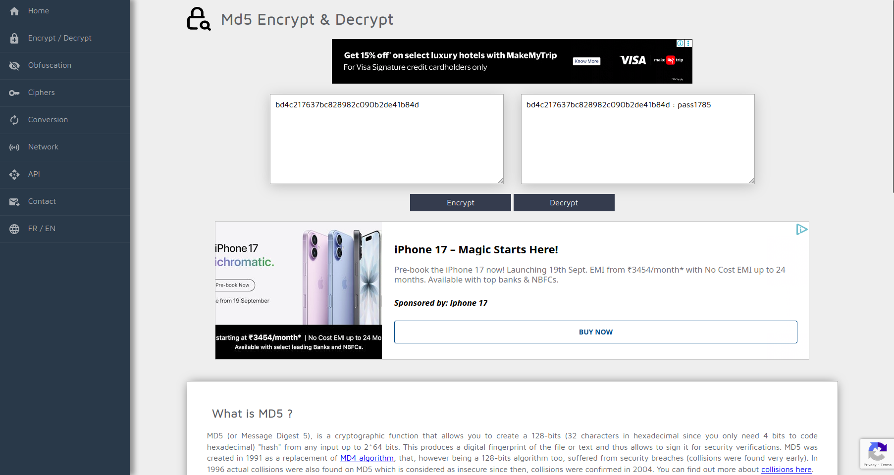
So the password is pass1785.

Objectives
- Find the key (DONE!!!)✅
- Find the Easter egg and decrypt - https://md5decrypt.net/en/ Have fun!) (DONE!!!)✅

